
J/105 Technical Bulletin April 24, 2001

To: J/105 Owners & Dealers
Fr: J Boats & TPI

Rudder Bearings
Since hull #1, J/105s have been spec’d with Harken rudder bearings. Harken recently announced that they were discontinuing manufacture of rudder bearings. If well maintained, the Harken bearings will last for several years, but if you’ve been sailing several seasons in salt water and your bearings have never been serviced, washed out or otherwise inspected, you may need to refurbish or replace your lower bearing. For hull numbers 1-#467, the recommended replacement bearing is the Jefa bearing from PYI in Seattle. Jefa bearings are very high quality, built in Denmark and are featured on many prominent racing and cruising designs. Jefa has designed a bearing to fit the current recess on existing J/105s. You can gather more info at www.pyiinc.com or Tel 800-523-7558. The PYI part number for the lower bearing and sleeve is #0641J105. Cost is $731.25. The upper bearing and sleeve is part #0642J105 and is $612.50

As of hull #468, boats will be provided with a newly engineered Edson bearing. Edson, who already provides the wheel, quadrant and steering cables is now providing TPI with a full steering package solution. The bearings are roller-type that feature easy-to-clean components which should provide owners a long life. Due to the nature of Edson’s bearing design, re-fits are only possible if a new recess is glassed into the boat.

Companionway Slider Stop
If the crew aggressively slides the companionway slider shut, the edges can sometimes chip the gelcoated stops at the aft end of the slider track. Two solutions have been suggested for this. One is simply super-gluing some rubber bumpers on the forward face of the stops to cushion the blow. The second is to install a lanyard under the seahood (out of sight) that limits the travel of the hatch. The lanyard runs from the front of the slider forward to a padeye installed under the front of the seahood. Adjust the lanyard so that the slider stops about 3/8” from the end.

Hull to Deck Joint
J/105 hulls and decks are bonded together with Plexus, a 3M high strength glue for commercial use only; the same stuff they build airplanes out of. The finish caulking around the seam is Sikaflex, readily available at West Marine. Leaks at the hull to deck joint are rare, but if you find one, 3M 5200 adhesive is the best material to use. If you are just seeing the cosmetic caulking peeling out, simply scrape out and apply new Sikaflex.

Mast Tuning and Mast Bend
There have been a handful boats in the last few seasons who have reported developing slight but permanent fore/aft bends in the top tapered section of their mast. Any combination of excessive headstay length, loose lower shrouds, and overcranked backstay could lead to a scenario where the mast is being “overbent.” On many boats without runners you have the visual clue of seeing inversion wrinkles in the mainsail to indicate that too much backstay is on. However, many of the J/105 mainsails are designed fuller (to provide power when sailing in the class configuration in light), making it possible to exceed recommended mast bend without inverting the mainsail.

Hall Spars recommends no more than 9 inches of bend in the mast, as measured by taking the main halyard shackle to the gooseneck, and measuring the distance between the halyard and the aft side of the mast at its widest point (usually between the upper and lower spreaders). We recommend that, with the rig tuned for racing, you pump down the backstay until reaching the maximum recommended bend, then marking your backstay adjuster as a reference. As an additional precaution, you can install a spacer stop above the cylinder to ensure that no one overcranks the backstay. If you want to generate more headstay tension when the mast is at full bend, then release the backstay, take up more turns on the lower shrouds and/or the headstay, and then retrim the backstay.

Owners who sail in predominately light air areas should be most attentive; because for most of their sailing, the sailmakers recommend loose lower shrouds as being fastest; just don’t forget to tighten them up when it’s windy. If you want to set your rig up once and not fool with it, make sure the lower shrouds are tensioned to at least hand tight plus 2-4 turns.

Engine Stop Cable
Some owners of wheel equipped J/105s have been reporting having difficulty with their engine stop cables. In particular, they have found them difficult to pull out, especially after some time in salty climate. In most cases, just keeping them lubed will do the trick. Up until now, wheel equipped boats have had the cable run to the port side of the binnacle. Because Yanmar only provides the cable in fixed lengths, TPI has coiled any extra length and wire-tied the cable inside the binnacle. A J/105 class website posting suggested that owners undo some of the wire ties to improve the cable action. However, we know of one instance where an owner, while motoring, turned his boat sharply and the stop cable caught on the clevis pin connecting the steering chain to the cable. Before sailing again, please be sure to check the run of your stop cable and be sure the cable is clear from any moving parts.

To help improve the action and to reduce the chance of the above incident, TPI has specified a new location for the stop cable: centerline aft, inside the recess for the engine panel. The cable has a straight shot out of the starboard side of the engine, aft along the upper inboard side of the fore/aft partion (between engine/steering and starboard cockpit locker), wire tied to the starboard cockpit support tube (inside aft lazarette) and looped around to the panel. This is a straight run, and reachable by the Yanmar stop cable fitted on most current J/105s. The change only involves drilling one small hole. Both tiller and wheel boats will now have the same location.

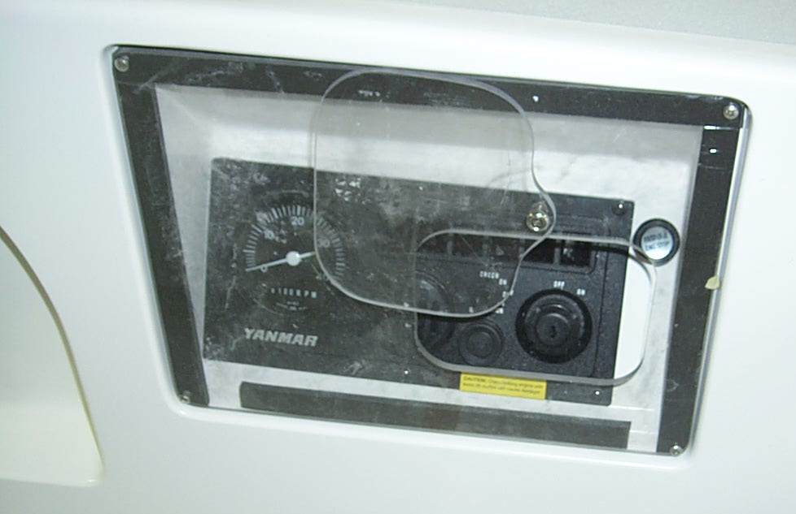

Bowsprit Seals
TPI has sourced a new bowsprit “lip” seal, which has been standard on new boats since hull #336. The seal can be trimmed to fit any J/105 bowsprit. It is then superglued into the sprit housing recess, and secured with a retainer ring with self-tapping stainless screws. TPI is ordering an extra supply of seals and retainer rings to accommodate owners interested in refitting their boats. Cost including shipping is $75. Best to email TPI at custserv@tpicomp.com or call Tel 401-247-1050.

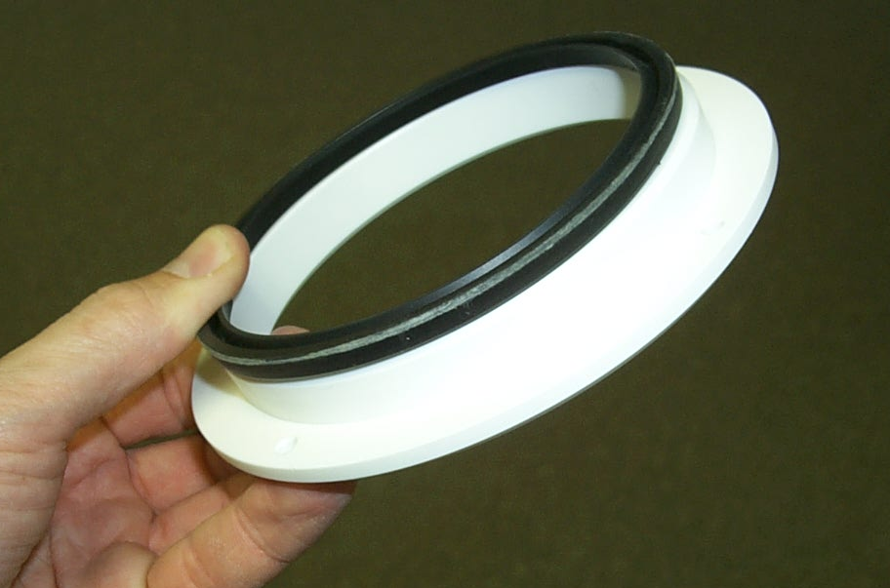

Battery Specs
Although the make, model and spec description have changed, the same basic lead acid battery has been installed on the J/105 since Hull #1. It was a carry over of the battery used in the J/35. There has not been much issue with the battery, because most J/105s are lightly equipped in electronics, and not carrying high-amp drawing items like auto-pilots, SSBs, etc. The lead acid battery matches the standard Yanmar engine/alternator well, because the Yanmar’s internal regulator is non adjustable and outputs up to 14.2 volts, which is higher than gelcells prefer. However, it does not provide the extended deep cycle capability desired for longer passages. Recently, an owner who has been doing more long distance-type sailing expressed disappointment with the current battery capacity to handle electrical needs, especially when sailing at night. Based on this input, TPI has changed battery suppliers and battery specs. As of approximately hull #462, the new standard battery will be a Group 24 by MB Sportsman Marine/RV Batteries. Their Part Number is DC24 and measures 10 1/4” long x 6 3/4” wide x 9 3/4” high. The supplier is Mid State Battery in Connecticut at TEL 800-444-1486 or website at http://www.midstatebattery.com/marine.htm

